Database Technologies Lab Sheet — 5
Course Code: MCA105P
Database, Tables & Advance User Accounts —
50 Practice Problems Sec ons: A – Easy (20) · B – Medium (20) · C – Hard (10)
Coverage: DCL and its types

CREATE DATABASE CollegeJoinDB;
USE CollegeJoinDB;

CREATE TABLE Departments (
DeptID INT PRIMARY KEY,
DeptName VARCHAR(50),
Location VARCHAR(50)
);

CREATE TABLE Employees (
EmpID INT PRIMARY KEY,
EmpName VARCHAR(50),
DeptID INT,
Salary DECIMAL(10,2),
City VARCHAR(50)
);

CREATE TABLE SalaryGrades (
Grade CHAR(2) PRIMARY KEY,
MinSalary DECIMAL(10,2),
MaxSalary DECIMAL(10,2)
);

INSERT INTO Departments VALUES
(10, 'Computer Science', 'Block A'),
(20, 'Pharmacy', 'Block B'),
(30, 'Management', 'Block C'),
(40, 'Civil Engineering', 'Block D');

INSERT INTO Employees VALUES
(101, 'Aarav', 10, 65000, 'Delhi'),
(102, 'Priya', 20, 72000, 'Mumbai'),
(103, 'Rahul', 10, 48000, 'Delhi'),
(104, 'Sneha', 30, 91000, 'Pune'),
(105, 'Vikram', 20, 55000, 'Jaipur'),
(106, 'Neha', 50, 80000, 'Bengaluru'),
(107, 'Kabir', 30, 43000, 'Pune');

INSERT INTO SalaryGrades VALUES
('G1', 0, 49999),
('G2', 50000, 69999),
('G3', 70000, 89999),
('G4', 90000, 120000);

SELECT Employees.EmpName, Departments.DeptName, Departments.Location
FROM Employees
INNER JOIN Departments ON Employees.DeptID = Departments.DeptID;

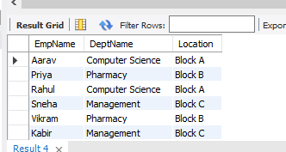

SELECT Employees.EmpID, Employees.EmpName, Employees.DeptID, Departments.DeptName
FROM Employees
INNER JOIN Departments ON Employees.DeptID = Departments.DeptID;

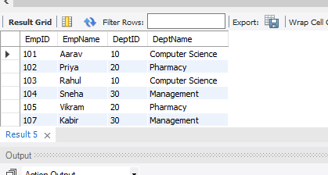
SELECT Employees.*
FROM Employees
INNER JOIN Departments ON Employees.DeptID = Departments.DeptID
WHERE Departments.DeptName = 'Pharmacy';
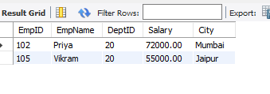
SELECT Employees.*
FROM Employees
INNER JOIN Departments ON Employees.DeptID = Departments.DeptID
WHERE Employees.Salary > 60000;
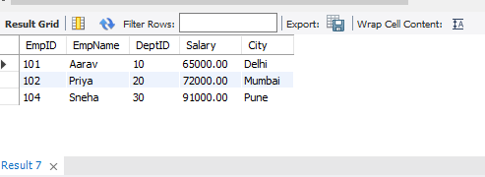

SELECT * FROM Employees, Departments
WHERE Employees.DeptID = Departments.DeptID;
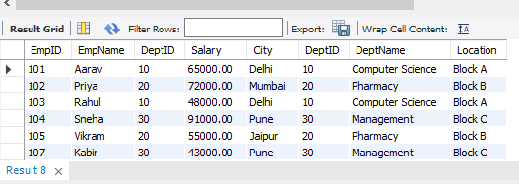

SELECT Employees.EmpName, Employees.City, Departments.DeptName, Departments.Location
FROM Employees, Departments
WHERE Employees.DeptID = Departments.DeptID;
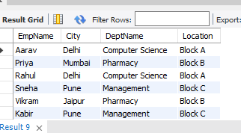
SELECT Employees.*
FROM Employees
INNER JOIN Departments ON Employees.DeptID = Departments.DeptID
WHERE Departments.DeptName = 'Computer Science';
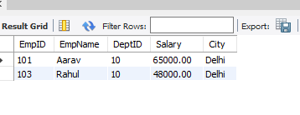
SELECT Employees.EmpName, Employees.Salary, SalaryGrades.Grade, SalaryGrades.MinSalary
FROM Employees
JOIN SalaryGrades ON Employees.Salary > SalaryGrades.MinSalary;
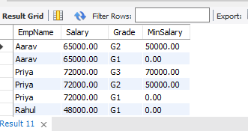
SELECT Employees.EmpName, Employees.Salary, SalaryGrades.Grade
FROM Employees
JOIN SalaryGrades ON Employees.Salary >= SalaryGrades.MinSalary AND Employees.Salary <= SalaryGrades.MaxSalary;

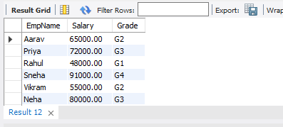
SELECT Employees.EmpName, SalaryGrades.Grade
FROM Employees
JOIN SalaryGrades ON Employees.Salary < SalaryGrades.MaxSalary;

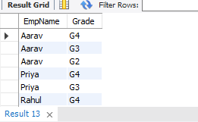
SELECT Employees.EmpName, Employees.Salary, SalaryGrades.Grade
FROM Employees
JOIN SalaryGrades ON Employees.Salary >= SalaryGrades.MinSalary;
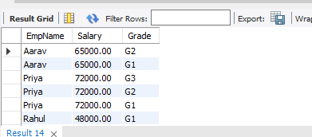
SELECT EmpName, DeptID, DeptName
FROM Employees
NATURAL JOIN Departments;
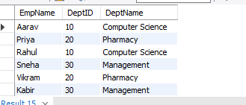
SELECT *
FROM Employees
NATURAL JOIN Departments
WHERE Location = 'Block B';
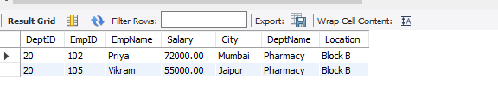
SELECT EmpName, DeptName, Salary
FROM Employees
NATURAL JOIN Departments
WHERE Salary >= 70000;

SELECT Employees.EmpName, Departments.DeptName, Employees.Salary
FROM Employees
INNER JOIN Departments ON Employees.DeptID = Departments.DeptID
ORDER BY Employees.Salary DESC;

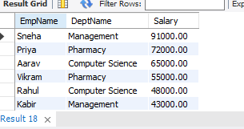
SELECT DISTINCT Departments.DeptName
FROM Employees
INNER JOIN Departments ON Employees.DeptID = Departments.DeptID;
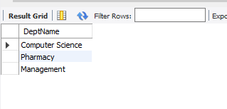
SELECT Departments.DeptName, COUNT(Employees.EmpID) AS Employee_Count
FROM Employees
INNER JOIN Departments ON Employees.DeptID = Departments.DeptID
GROUP BY Departments.DeptName;
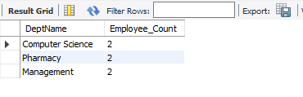
SELECT Departments.DeptName, AVG(Employees.Salary) AS Average_Salary
FROM Employees
INNER JOIN Departments ON Employees.DeptID = Departments.DeptID
GROUP BY Departments.DeptName;
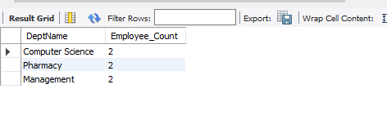 SELECT Departments.DeptName, AVG(Employees.Salary) AS Avg_Salary
FROM Employees
INNER JOIN Departments ON Employees.DeptID = Departments.DeptID
GROUP BY Departments.DeptName
HAVING AVG(Employees.Salary) > 60000;
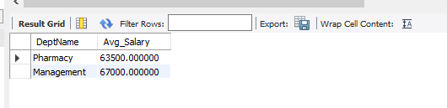
SELECT Employees.EmpName, Departments.DeptName, Employees.Salary
FROM Employees
INNER JOIN Departments ON Employees.DeptID = Departments.DeptID
ORDER BY Employees.Salary DESC
LIMIT 1;

SELECT Employees.*
FROM Employees
INNER JOIN Departments ON Employees.DeptID = Departments.DeptID
WHERE Departments.DeptName IN ('Computer Science', 'Pharmacy');
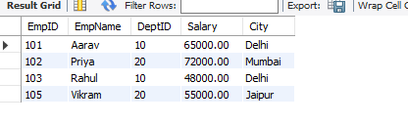
SELECT Employees.*, Departments.DeptName
FROM Employees
INNER JOIN Departments ON Employees.DeptID = Departments.DeptID
WHERE Employees.City IN ('Delhi', 'Pune') AND Employees.Salary >= 50000;
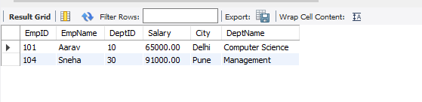
SELECT DeptName, COUNT(EmpID) AS Employee_Count
FROM Employees
NATURAL JOIN Departments
GROUP BY DeptName;
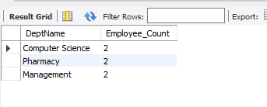
SELECT Departments.DeptName, SUM(Employees.Salary) AS Total_Salary
FROM Employees
INNER JOIN Departments ON Employees.DeptID = Departments.DeptID
GROUP BY Departments.DeptName
HAVING SUM(Employees.Salary) > 100000;
